**C:\Users\st11223\Desktop\MIT LOGO ETC\New MIT Logo.png **

**NEW ZEALAND MARITIME SCHOOL**

**NZ Diploma in Marine Electro-technology (NZ2894)**

**(STCW 1978 A-III/6, as amended in 2010)**

**Electro-Technical Officer, Year 2 Cadets, 2020.**

**Course Code**

942.634 – PC01.

**Course Title**

Operation of Generators and Distribution Systems.

Practical Assessment.

**Format**

PLC Program including flow chart diagrams and marked Competent (C) or Not-Yet Competent (NYC). Weighting = 50%.

**Due Date**

To be submitted by email to [nick.cossar@manukau.ac.nz](mailto:nick.cossar@manukau.ac.nz) for the due date of 31/05/2020.

**Tutor**

Nick Cossar

[nick.cossar@manukau.ac.nz](mailto:nick.cossar@manukau.ac.nz)

**Student Name:**

**Student ID:**

**Date:**

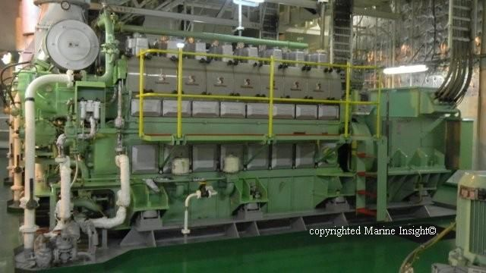

# PLC Programming Assignment

**(1000 kW) Diesel Generator automatic start up sequence**

### *Note- reading of Generator and synchronising conditions in course support material on Canvas is recommended*

### Objective

To produce a logic program for the automatic start up a diesel generator and synchronising to a live LV switch board.

This control to be completed using the Siemens S7 PLC.

### General Description

The automatic start of a diesel generator must follow a defined start procedure programmed as a sequence.

The start & stop sequence is initiated by the operator from a N/O Start Push button (switch 8) and the N/O Stop Pushbutton (switch 9 ) when in manual mode.

Most operational steps are required to be completed in a predefined but adjustable time period. If the time for a step expires then a failure signal is generated and the procedure aborted or retried for a specified number of times.

The main “Start Up” steps are as follows:

1. Start Diesel engine
2. Synchronise when speed & voltage are correct (analogue input/comparison section)
3. Load the Generator

### Start Up Conditions

Generator must be ready which normally requires several preconditions to be met. E.g. Circuit Breaker (CB Ready - not tripped, no Earth/Fault, no alarm, CB off)

Diesel Generator (DG) in Automatic and Ready (no alarms, not running).

For this project we will assume that if the Diesel is ready and all these preconditions have been met, then a particular digital input is on.

However, it should not be possible to initiate the start-up sequence if the generator is running or if the CB is faulted or not open.

### Detailed Start-up Procedure

1. Operator closes manual start push-button to start the start-up sequence
2. Start Diesel pre-lubrication pump if conditions permit. These conditions include a precondition input being true.
3. If Lube Oil pressure is OK within 20 seconds, Start Diesel by activating the compressed air start solenoid.
4. When the compressed air start solenoid activated signal is received within 5 seconds, stop the pre-lube pump and continue, else sound the alarm and sequence is aborted.
5. Wait up to 1 minute for the generator to warm up and get to speed
6. Then after warm up, if the Diesel is up to speed and generator voltage in range (analogue section), if all synchronising conditions are correct, then close the generator CB, else sound the alarm and do not proceed with closing the CB
7. If CB closes within the allowed time period of 2 seconds, turn on the generator sharing controller, else sound the alarm and do not proceed
8. The sequence may only be restarted after an alarm condition - if the alarm is first acknowledged and reset the alarm condition

### PLC Digital Inputs

1. Start Push button N/O Switch I:0.0
2. Emergency Stop N/C Switch I:0.1
3. Stop Push button N/C Switch I:0.2
4. Engine Preconditions OK Switch I:0.3
5. Diesel Lube pressure OK Switch I:0.4
6. Air Solenoid activated Switch I:0.5
7. Circuit Breaker contactor close Switch I:0.6
8. Alarm Acknowledge push button Switch I:0.7
9. Alarm Reset Switch I:0.8
10. Circuit breaker, protection trip input signals Switch I:0.9

### PLC Analog Inputs - use when synchronising generator onto the live switchboard (Siemens S7 1200 2M 0 – 1 Analog inputs)

1. (A0) - Generator speed/generated frequency (60HZ)
2. (A1)- Voltage across the incoming generator and switchboard 0-10 volts

(2 inputs available on the Siemens S7 1200 PLC)

**PLC Analog Output –** 1 is available on S7 1200, can be configured as 0-10 V or 4-20mA – optional use for displaying the generator frequency to a digital multimeter.

### PLC Digital Outputs

1. Start sequence in progress indicator lamp Q:0.0
2. Diesel Lube Pump run Q:0.1
3. Start Diesel air solenoid valve Q:0.2
4. Close Circuit Breaker Q:0.3
5. Generator is sharing load (kW and kVar) lamp Q:0.4
6. General Alarm siren/beacon Q:0.5
7. Fuel solenoid to control the shut-down of the diesel Q:0.6

### PLC Timers

1. Prelube timer
2. Warm-up timer
3. Air Solenoid timer

### PLC Counters

1. Circuit breaker operations (10,000 count service life)
2. Total running hours (real-time clock or timer to counts)
3. Filters change for Fuel/lube 250 hours with watch-keeping officer reset
4. Turbo charger water wash 500 hours with watch-keeping officer reset

**PLC Internal Bits (internal relays)**

Fuel pump and fuel is available to start/run M:1.0

Complete a Flow chart diagram (use MS Visio / Word etc) and documentation to include detailed description of each Siemens Network

**Resources**

* + CANVAS course 1.
  + Hall – Practical Marine Electrical Knowledge.
  + Hughes – Electrical and Electronic Technology.
  + Shaum – Outline of Theory and Problems.
  + Lloyds of London Rules and Regulations for the Classification of Ships July 2018.